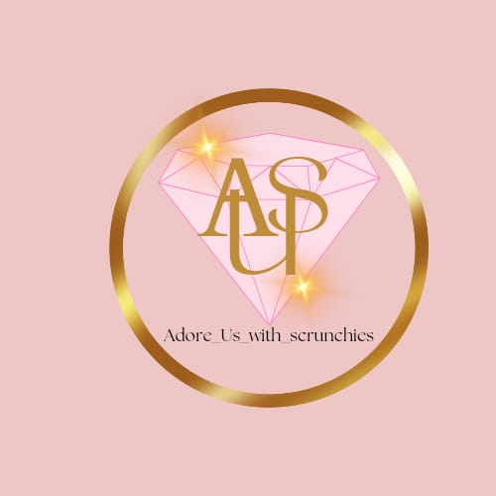**Adore Scrunchies**

Adore Us with Scrunchies

If you're looking for high-quality, handmade scrunchies that blend durability, comfort, and design, Adore Scrunchies is the place to go. Because they are made of premium materials, our scrunchies will fit you perfectly and won't pull, tug, or harm your hair. Whether you're dressing up for a night out or keeping it casual, there's a scrunchie for every occasion thanks to its diverse range of vivid colors, distinctive designs, and sizes.

**Why choose Adore Scrunchies?**

* **Soft on Hair**: Our scrunchies are the healthier option for all hair types because they are made to reduce breakage and split ends.
* **Extended Elasticity:** Bid adieu to slack, elongated scrunchies. All day long, a firm grasp is provided by our long-lasting elastics.
* **Fashion-Forward Designs**: With our always-changing selection of chic scrunchies that go well with every ensemble, you can stay on style.
* **Eco-Friendly Materials**: We use minimal packaging and eco-friendly textiles since sustainability is important to us.
* **Kind and Soft Fabric**: Our scrunchies are made of premium fabrics and are intended to be kind on hair, which helps to prevent breakage and tangles.
* **Versatile Styles**: Our scrunchies suit well with any ensemble, whether you're dressing up or down. They come in a range of colors and designs.
* **Stretchy & Sturdy**: Even after frequent usage, the elastic construction keeps its shape and durability, guaranteeing a snug fit.
* **No-Crease Design:** Suitable for both casual and professional situations, these scrunchies leave hair appearing smooth and crease-free for the whole day.

**Benefits:**

* **Comfortable Wear**: Our scrunchies hold your hair firmly without pulling or creating discomfort, so you may enjoy all-day comfort.
* **Fashion-Forward Accessory:** Our chic designs will effortlessly add a pop of color and elegance to your ensemble.
* **Perfect for Every Type of Hair:** Regardless of your hair type—thick, thin, curly, or straight—our scrunchies provide an adaptable and useful option.

**Why Choose Us?**

Our scrunchies are a fashion and functional statement rather than merely a hair accessory. They are a wonderful addition to any accessory collection and are ideal for both regular use and special events.   
Adore Scrunchies will up your hair game because they combine style and quality.

***Discover the ideal scrunchie for you by shopping now!***

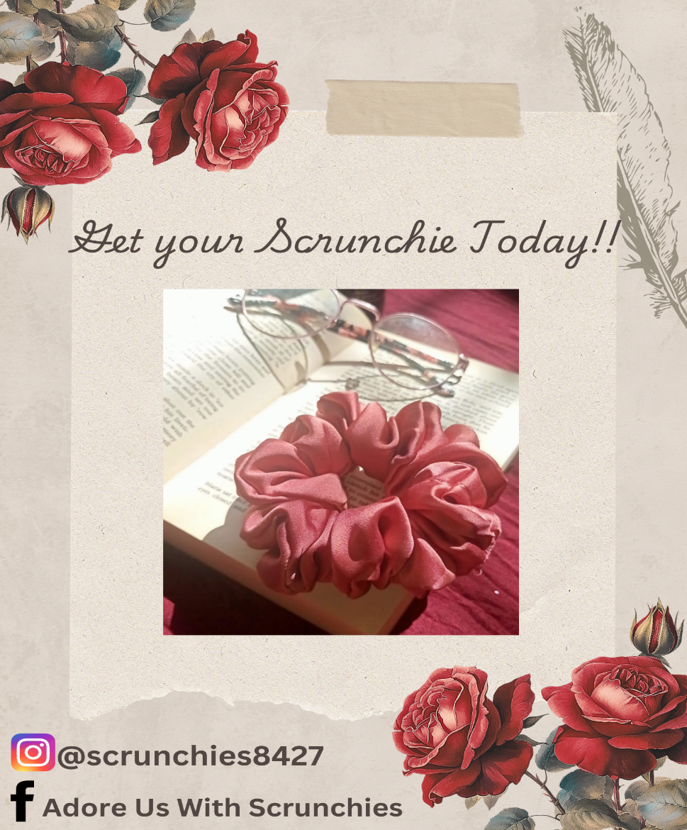

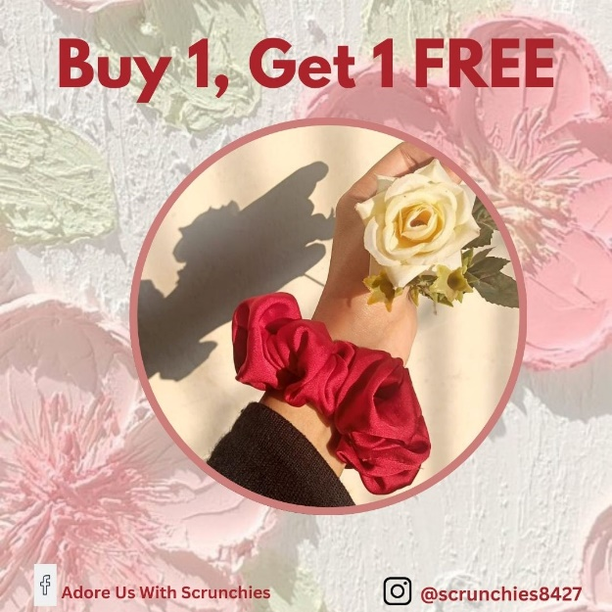

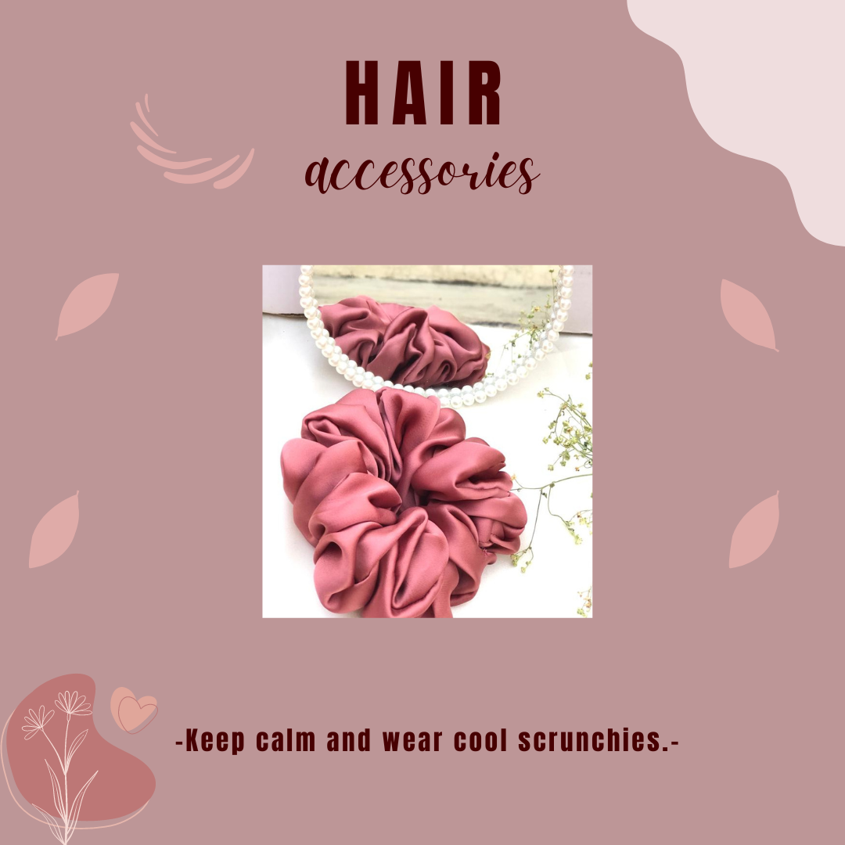

**SEO Keywords**:

premium scrunchies, handmade hair accessories, stylish scrunchies, durable hair ties, eco-friendly scrunchies, gentle hair accessories.

Facebook:

<https://www.facebook.com/profile.php?id=61563772342549>

Instagram:

<https://www.instagram.com/scrunchies8427?igsh=MWJzbnQzdzlqaWF3bw==>